**MANUAL TESTING**

**What do you mean by testing?**

Software testing is **the process of evaluating and verifying that a software product or application does what it is supposed to do**. The benefits of testing include preventing bugs, reducing development costs and improving performance.

**What is project?**

A project is defined as **a sequence of tasks that must be completed to attain a certain outcome**.

**Types of Software Development**

* Frontend Development.
* Frontend developers work on the part of the product with which the user interacts.
* Backend Development.
* Full-Stack Development.
* Desktop Development.
* Web Development.
* Database Development.
* Mobile Development.
* Cloud Computing.

**Types of Projects:**

* Manufacturing Projects
* Construction Projects
* Management Projects
* Research Projects

**What are 5 characteristics of a project?**

* Specific. The project must be specific.
* Measurable. A clearly defined project must be measurable in terms of its benefits and achievements.
* Achievable. A project will only be meaningful if it is achievable.
* Relevant. The project needs to bring relevant benefits to the entity concerned.
* Time bound.

**What is product?**

* Application Software.
* System Software.
* Programming Software.
* While application software is designed for end-users, and system software is designed for computers or mobile devices, programming software is for computer programmers and developers who are writing code.
* Driver Software.

**What is Quality?**

Quality refers to **the conformance to implicit or explicit requirements, expectations, and standards**. In order to fulfil these requirements, a quality control mechanism is set up. Quality Control (QC) is the process through which you achieve, or improve, product quality.

**Software Development Life Cycle (SDLC) Phases**

* Requirement Gathering and Analysis
* Design
* Implementation or Coding
* Testing
* Deployment
* Maintenance

**Software Development Life Cycle Models**

* Waterfall Model
* V-Shaped Model
* Prototype Model
* Spiral Model
* Iterative Incremental Model
* Big Bang Model
* Agile Model

[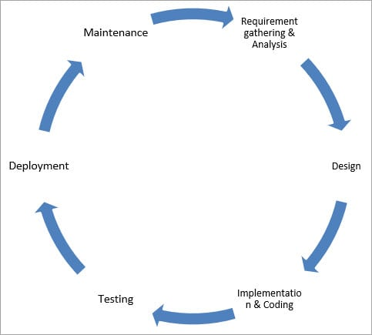](https://www.softwaretestinghelp.com/wp-content/qa/uploads/2018/04/SDLC-Cycle.jpg)

**SDLC Phases**

**Given below are the various phases:**

* Requirement gathering and analysis
* Design
* Implementation or coding
* Testing
* Deployment
* Maintenance

**1) Requirement Gathering and Analysis**

During this phase, all the relevant information is collected from the customer to develop a product as per their expectation. Any ambiguities must be resolved in this phase only.

Business analyst and Project Manager set up a meeting with the customer to gather all the information like what the customer wants to build, who will be the end-user, what is the purpose of the product. Before building a product a core understanding or knowledge of the product is very important.

**For Example,** A customer wants to have an application which involves money transactions. In this case, the requirement has to be clear like what kind of transactions will be done, how it will be done, in which currency it will be done, etc.

Once the requirement gathering is done, an analysis is done to check the feasibility of the development of a product. In case of any ambiguity, a call is set up for further discussion.

Once the requirement is clearly understood, the SRS (Software Requirement Specification) document is created. This document should be thoroughly understood by the developers and also should be reviewed by the customer for future reference.

**2) Design**

In this phase, the requirement gathered in the SRS document is used as an input and software architecture that is used for implementing system development is derived.

**3) Implementation or Coding**

Implementation/Coding starts once the developer gets the Design document. The Software design is translated into source code. All the components of the software are implemented in this phase.

**4) Testing**

Testing starts once the coding is complete and the modules are released for testing. In this phase, the developed software is tested thoroughly and any defects found are assigned to developers to get them fixed.

Retesting, regression testing is done until the point at which the software is as per the customer’s expectation. Testers refer SRS document to make sure that the software is as per the customer’s standard.

**5) Deployment**

Once the product is tested, it is deployed in the production environment or first UAT (User Acceptance testing) is done depending on the customer expectation.

In the case of UAT, a replica of the production environment is created and the customer along with the developers does the testing. If the customer finds the application as expected, then sign off is provided by the customer to go live.

**6) Maintenance**

After the deployment of a product on the production environment, maintenance of the product i.e., if any issue comes up and needs to be fixed or any enhancement is to be done is taken care by the developers.

**STLC**

**Software Testing Life Cycle (STLC)** is a sequence of different activities performed during the software testing process.

In the initial stages of STLC, while the software product or the application is being developed, the testing team analyses and defines the scope of testing, entry and exit criteria and also the test cases. It helps to reduce the test cycle time and also enhance the product quality.  
As soon as the development phase is over, testing team is ready with test cases and start the execution. This helps in finding bugs in the early phase.

**Phases of STLC:**  
  
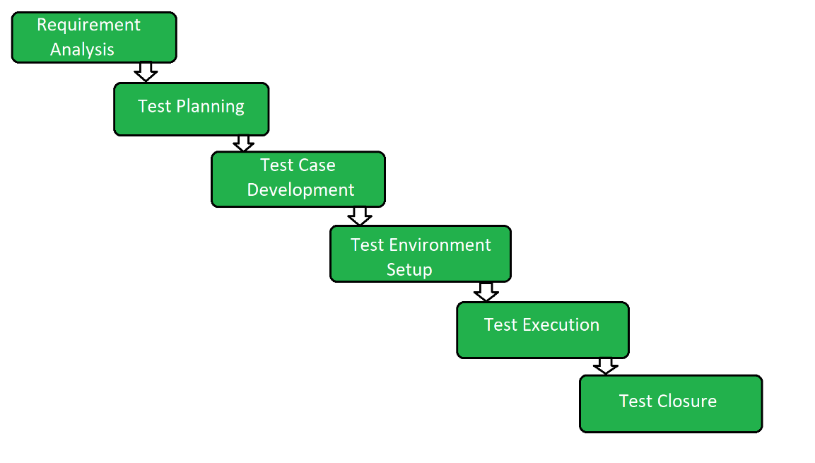

1. **Requirement Analysis:**  
   Requirement Analysis is the first step of Software Testing Life Cycle (STLC). In this phase quality assurance team understands the requirements like what is to be tested. If anything is missing or not understandable then quality assurance team meets with the stakeholders to better understand the detail knowledge of requirement.
2. **Test Planning:**  
   Test Planning is most efficient phase of software testing life cycle where all testing plans are defined. In this phase manager of the testing team calculates estimated effort and cost for the testing work. This phase gets started once the requirement gathering phase is completed.
3. **Test Case Development:**  
   The test case development phase gets started once the test planning phase is completed. In this phase testing team note down the detailed test cases. Testing team also prepare the required test data for the testing. When the test cases are prepared then they are reviewed by quality assurance team.
4. **Test Environment Setup:**  
   Test environment setup is the vital part of the STLC. Basically, test environment decides the conditions on which software is tested. This is independent activity and can be started along with test case development. In this process the testing team is not involved. either the developer or the customer creates the testing environment.
5. **Test Execution:**  
   After the test case development and test environment setup test execution phase gets started. In this phase testing team start executing test cases based on prepared test cases in the earlier step.
6. **Test Closure:**  
   This is the last stage of STLC in which the process of testing is analysed.

**Testing phase**

4 stages of software testing

[[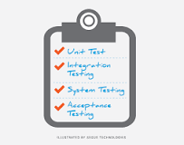](https://www.google.com/search?rlz=1C1GCEJ_enIN854IN854&sxsrf=ALiCzsaId85aheKDoy8ROJvWEQVVdVR7rA:1651661508077&q=What+are+the+4+stages+of+software+testing?&tbm=isch&source=iu&ictx=1&vet=1&fir=Ap6-4dhPcpcXpM%252Cs69Dn_Uf87f3mM%252C_&usg=AI4_-kTrfkN463sLVzIEGMGgLQGBtNgV6g&sa=X&ved=2ahUKEwjRoenL1sX3AhW1TGwGHXYbCsEQ9QF6BAgUEAE#imgrc=Ap6-4dhPcpcXpM)](https://www.google.com/search?rlz=1C1GCEJ_enIN854IN854&sxsrf=ALiCzsaId85aheKDoy8ROJvWEQVVdVR7rA:1651661508077&q=What+are+the+4+stages+of+software+testing?&tbm=isch&source=iu&ictx=1&vet=1&fir=Ap6-4dhPcpcXpM%252Cs69Dn_Uf87f3mM%252C_&usg=AI4_-kTrfkN463sLVzIEGMGgLQGBtNgV6g&sa=X&ved=2ahUKEwjRoenL1sX3AhW1TGwGHXYbCsEQ9QF6BAgUEAE" \l "imgrc=Ap6-4dhPcpcXpM)

There are four main stages of testing that need to be completed before a program can be cleared for use: **unit testing, integration testing, system testing, and acceptance testing**

**Levels of testing**

Software Testing is an activity performed to identify errors so that errors can be removed to obtain a product with greater quality. To assure and maintain the quality of software and to represents the ultimate review of specification, design, and coding, Software testing is required.

There are different levels of testing:

1. **Unit Testing:**  
   In this type of testing, errors are detected individually from every component or unit by individually testing the components or units of software to ensure that if they are fit for use by the developers. It is the smallest testable part of the software.
2. **Integration Testing:**  
   In this testing, two or more modules which are unit tested are integrated to test i.e., technique interacting components and are then verified if these integrated modules work as per the expectation or not and interface errors are also detected.
3. **System Testing:**  
   In system testing, complete and integrated Softwares are tested i.e., all the system elements forming the system is tested as a whole to meet the requirements of the system.
4. **Acceptance Testing:**  
   It is a kind of testing conducted to ensure whether the requirement of the users is fulfilled prior to its delivery and the software works correctly in the user’s working environment.

These testing can be conducted at various stages of software development. The levels of testing along with the corresponding software development phase is shown by the following diagram –

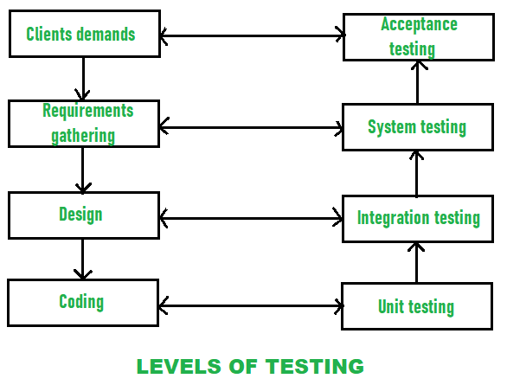

While performing the software testing, following Testing principles must be applied by every software engineer:

* The requirements of customers should be traceable and identified by all different tests.
* Planning of tests that how tests will be conducted should be done long before the beginning of the test.
* The Pareto principle can be applied to software testing- 80% of all errors identified during testing will likely be traceable to 20% of all program modules.
* Testing should begin “in the small” and progress toward testing “in the large”.
* Exhaustive testing which simply means to test all the possible combinations of data is not possible.
* Testing conducted should be most effective and for this purpose, an independent third party is required.

**Environments:**

There 4 different environments in a software development team are shown below:

* Development environment
* Testing environment
* Staging/Pre-prod environment
* Production environment

**Development environment:**

The development environment is the first environment in software development which acts as the workspace for developers to do programming and other operations related to the creation of software and/or systems.

An integrated development environment (IDE) — a software package with extensive functions for authoring, building, testing, and debugging a program which is commonly used by software developers. Some programming software tools such as Microsoft Visual Studio, Eclipse, NetBeans, and other integrated development environments.

**Testing environment:**

The test environment is where testing teams evaluate the application/quality. program’s This also allows computer programmers to find out and solve any defects that may interfere with the application’s smooth operation or degrade the user experience.

The test environment is created by allocating storage, computing, and other resources needed for testing. This could include new physical/virtual devices set up for testing use cases defined by developers. For example, Selenium tests cannot run for the whole set of browsers through which you want your application to be accessible at the same time. This means that you either run tests sequentially or generate multiple test environments.

**Staging/Pre-Prod environment:**

When you generate the staging instance of an application, you are confident sufficient to reveal it to the immediate owner but not to users. You should run more tests before exposing to the latter group. The staging environment is similar to the pre-production in use.

The staging environment is frequently restricted to a small group of people. The only groups that can access the application in staging are those with whitelisted emails and IP addresses, as well as your developer team. The goal of a staging environment is to simulate production as much as possible.

**Production environment:**

When the end-user uses a web/mobile application, the program is operating on a production server. It’s been created in the production environment.

Tests can be carried out while the product is in production, and new features can be introduced safely at the same time. Feature flags allow you to show a future version of an app to a select few users while the rest continue to utilize the current version.

